MEDIA RELEASE
For immediate release May 2014
Tax depreciation – a useful tool to further your relationship with buyers

Each year thousands of new property investors work with real estate agents in NSW to search for and secure viable investment properties.
While most real estate agents are aware of tax depreciation and how it can create cash flow for property investors, many new investors remain unaware of this opportunity.
Research shows that 80 per cent of property investors are missing out on thousands in depreciation deductions. Depreciation is often missed because it is a non-cash deduction – the investor doesn’t need to spend money to claim it.
A comprehensive depreciation schedule from a qualified quantity surveyor helps property owners take advantage of property depreciation to end up with more cash in their pockets.
Educating Investors
BMT Tax Depreciation believes that there is an opportunity for agents to build goodwill with these investors by increasing their awareness of the value of depreciation deductions.
By putting depreciation schedules on the radar of buyers, agents may increase the perceived value of a property while demonstrating to clients that they are across all property related matters that may have positive outcomes for their client base.
This may not only help a sales process, but assist an agent generate repeat business.
Win-win
It’s important to remember that this situation can be a ‘win-win.’
If the buyer is made aware of depreciation schedules and their value, they can benefit from increased cash flow from the process. You as the agent benefit from the goodwill your efforts may have generated.
Tax depreciation tools
As a real estate professional, there are a range of tools available to help assist with this education process. One tool that you may not be aware of is a BMT Tax Depreciation Estimate which can show potential buyers the depreciation deductions their investment could be entitled to. These additional deductions will increase the cash returns available for the new owner, making the purchase more attractive to investors.
A tax depreciation estimate can be compiled for new developments free of charge. Please visit www.bmtqs.com.au/tax-depreciation-estimate for more information on this service.
BMT also runs personalised training for real estate agents and offices to better explain the benefits of depreciation and how best to communicate these to current and potential clients.
Property investors are always looking to maximise their investment return – and the best way to do this is by ensuring that they have a depreciation schedule which squeezes maximum deductions from their investment property.
By making buyers aware of depreciation schedules as early as possible, you as an agent have an opportunity to create a ‘win-win’ scenario.
Crunching the numbers
As an example, an investor who is looking at purchasing a property for $420,000 with an appraised rental of $490 per week would receive a total income of $25,480 per annum. The estimated expenses for the property (including interest rates and management fees) total $32,000 per annum. The following scenario shows the investor’s cash flow with and without depreciation. It demonstrates that a typical $420,000 unit will experience a total deduction of $11,500 in the first full financial year.
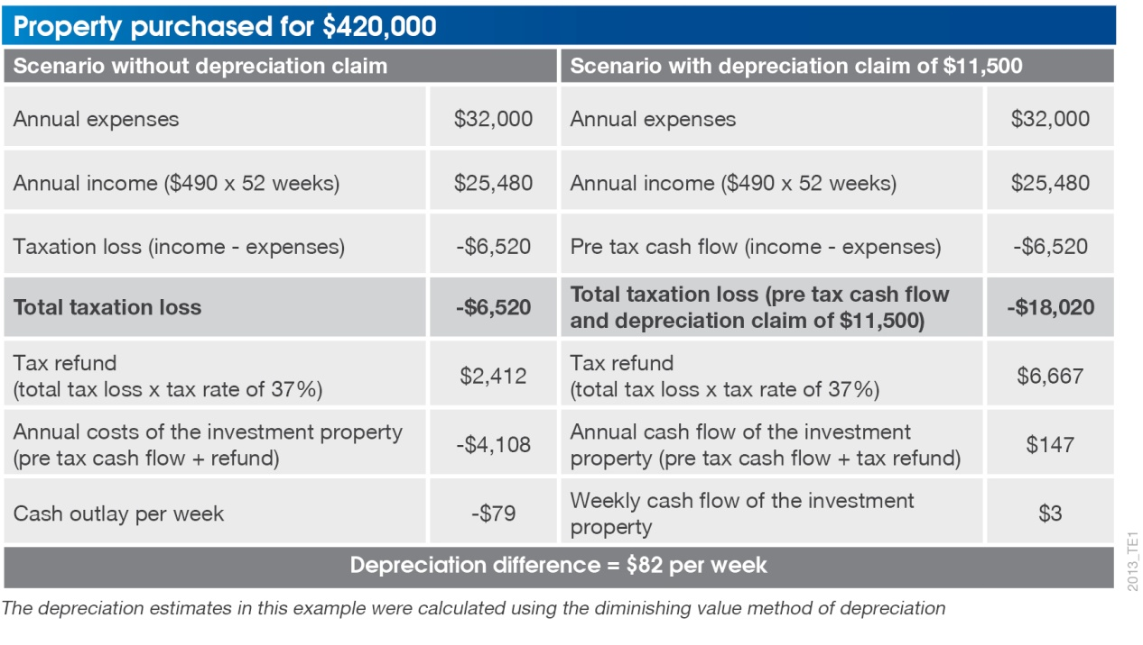
In this example the investor uses property depreciation to go from a negative cash flow scenario, paying out $79 per week, to a positive cash flow scenario, earning $3 per week on the property. By claiming depreciation this investor will save $4,255 in the first year alone.
*ENDS*
Media contact: Brad Beer, 0413 271 777, brad.beer@bmtnews.com.au
About BMT Tax Depreciation
BMT Tax Depreciation (BMT) is a Quantity Surveying company specialising in the provision of tax depreciation schedules for residential and commercial investment properties. Commencing business in 1997, demand from property investors nationally has seen business expand Australia-wide with offices now located in Sydney, Parramatta, Melbourne, Brisbane, Newcastle, Adelaide, Perth, Gold Coast, Cairns, Canberra, Hobart and Darwin.

